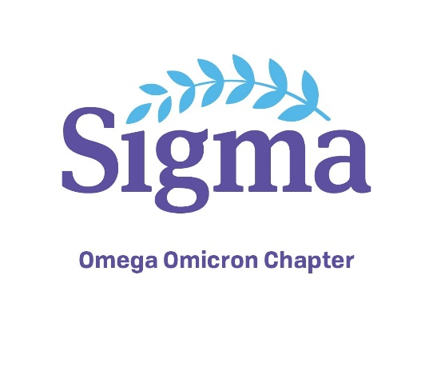
2021 Spring Summit (Virtual)
Nursing Leadership: Research, Resiliency, and Change
Presented by the Omega Omicron Chapter of Sigma Theta Tau International
March 30, 2021 8am-12:30pm CT

This practice/research conference is a forum for nurses, nursing students, and nursing faculty to share experiences and projects aimed at advancing rural nursing practice.

Target Audience: This conference is designed for nurses and nursing students interested in innovative topics to advance nursing practice (LPNs, RNs, nursing students).

Contact Hours: 4 peer-reviewed contact hours

Upon completion of the program, participants will:
- Describe the role of nursing research and the impact on leaders, managers, and nursing practice improvement
- Describe the attributes needed by nurse leaders to embrace and manage through change
- Describe resiliency and its applicability to nurse leaders
Time | Topic | Presenter(s)/Speaker(s)
7:45am-8am | Logging in
8am-8:15am | Logistics & Welcome | Laura Hoffman, Program Committee Chair  Melissa Kidrowski, President
8:15am-9:15am | Embracing and Surviving Change | Faith Johnson
9:15am-10:15am | Nursing Research and the Path to Nursing Leadership | Anita Leveke, Julie Weldon, and Angela Shanahan
10:15am-10:45am | Break | Poster sessions (Zoom breakout room(s))
10:45am—12:15pm | Workforce Resiliency | Diane Whitehead and Mary Bemker
12:15pm | Award Announcements and Summit Evaluations | Angela Chesley, All participants

Registration Form

2021 Spring Summit: Nursing Leadership: Research, Resiliency, and Change

March 30, 2021 • 8am-12:30pm CT

Zoom (link emailed upon confirmation of conference registration and payment)
The 2021 Spring Summit Nursing Leadership: Research, Resiliency, and Change will be offered via Zoom on March 30, 2021 8 am to 12:30 pm.
After you register, you will receive a Zoom link via email. Please be sure to include your email address on the registration form.
Registration Deadline is March 16, 2021.
Name_____________________________________Email_____________________________________
Address_____________________________________________________________________________
City____________________________________ State_________ Zip Code___________
Employer____________________________________________________________________________
Registration Fee-- (please mark appropriate fee) (includes peer-reviewed contact hours)
Nurse Omega Omicron Non-Member: $75_______________________
Nurse Omega Omicron Member: $40_______________
Current Nursing Student is Free: Name of School & Program________________________________
All participants who become Omega Omicron Sigma Theta Tau members before the Summit will receive a voucher for a FREE 2022 Summit attendance. Once membership is verified, you will receive the voucher via email. Ongoing Omega Omicron membership is required to redeem the voucher in 2022.
Make Checks Payable to: Omega Omicron Nursing Honor Society
Mail registration sheet and check to:
Southwest Minnesota State University – Department of Nursing ST105
Attn: LeeAnn Teig, English and Nursing
1501 State Street, Marshall, MN 56258

**Registration deadline is March 16, 2021

For more information about the Spring Nursing Summit, contact Laura Hoffman at laura.hoffman1@smsu.edu.

