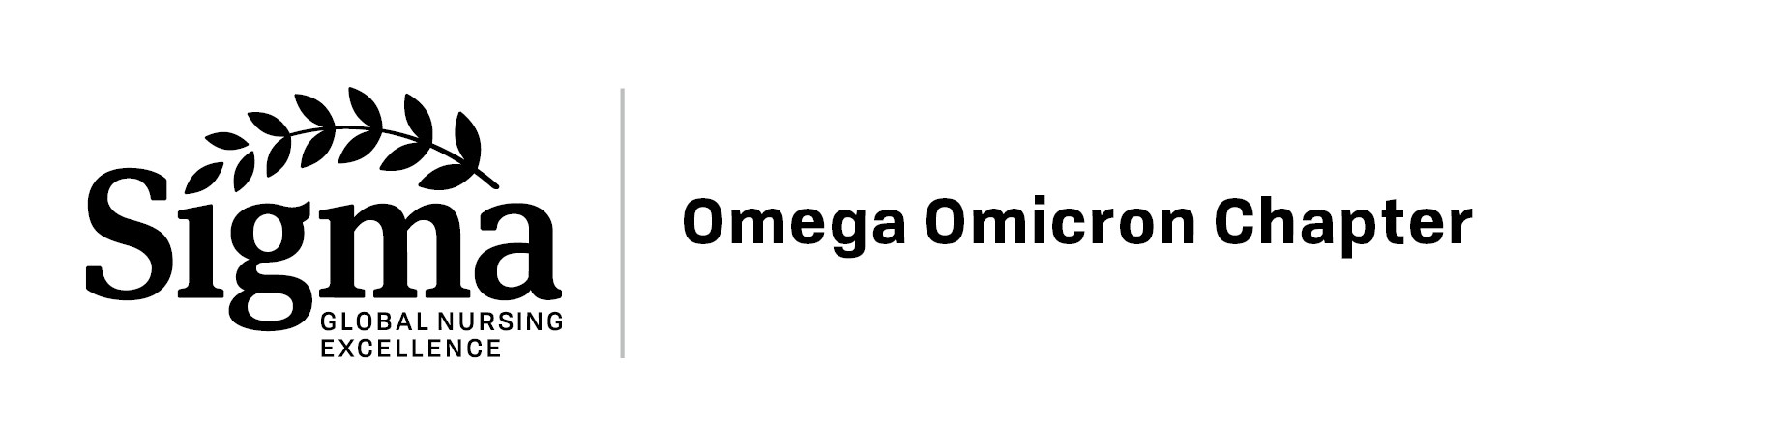Berniece E. Morris Memorial Scholarship Application

The Berniece E. Morris Scholarship is an annual $300 Memorial Academic Scholarship for Registered Nurses that are continuing their education in a formal academic program (RN to BSN, MSN, EdD, DNP, PhD, etc.).

Dr. Berniece E. Morris was a Psychologist who also taught college psychology courses and inspired many nursing students during their psychology coursework in their pre-nursing courses. Dr. Morris exemplified the characteristics of continuous self-improvement, generosity, and kind spirit.

Award Eligibility:
- Must be an Omega Omicron member in active/paid standing
- Must have a current nursing license and is currently practicing.
- Must be accepted and enrolled in a formal academic program.

Award Criteria:
- Provide a copy of a letter of acceptance to a formal academic program or evidence of current enrollment.
- Complete a Berniece E Morris Memorial Scholarship Application form.
- Summarize professional goals and ambitions in less than one page typed.
- Current Resume.
APPLICANT SECTION
Applicant Name: First: Last:

Address: Street and Number:

City/Town: State: Zip Code:

Phone #: Email Address:
EMPLOYMENT INFORMATION

Employer/Organization:

Employer Address:

Credentials/Certifications:

Role/Position:

Resume/CV Attached: Yes No

Please summarize professional goals and ambitions in less than one page typed.

- Tell the degree you are seeking (BSN, MSN, DNP, EdD, PhD, etc.)
- Tell the school and program where you are attending (Name and address)
- Describe your professional goals after you complete the degree program.
- How the scholarship would help you meet your professional goals and ambitions.

Please submit your application, letter of acceptance to the academic program which enrolled, AND resume/CV as an e-mail attachment to the email address listed on the website by the due date on the website at http://www.omegaomicron.org

